d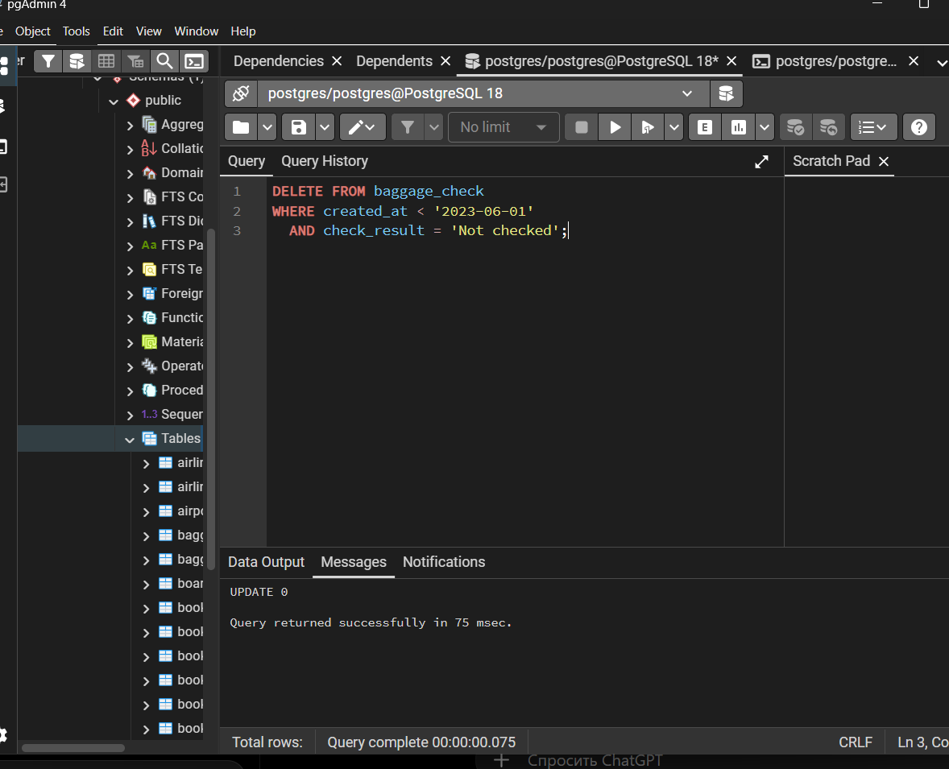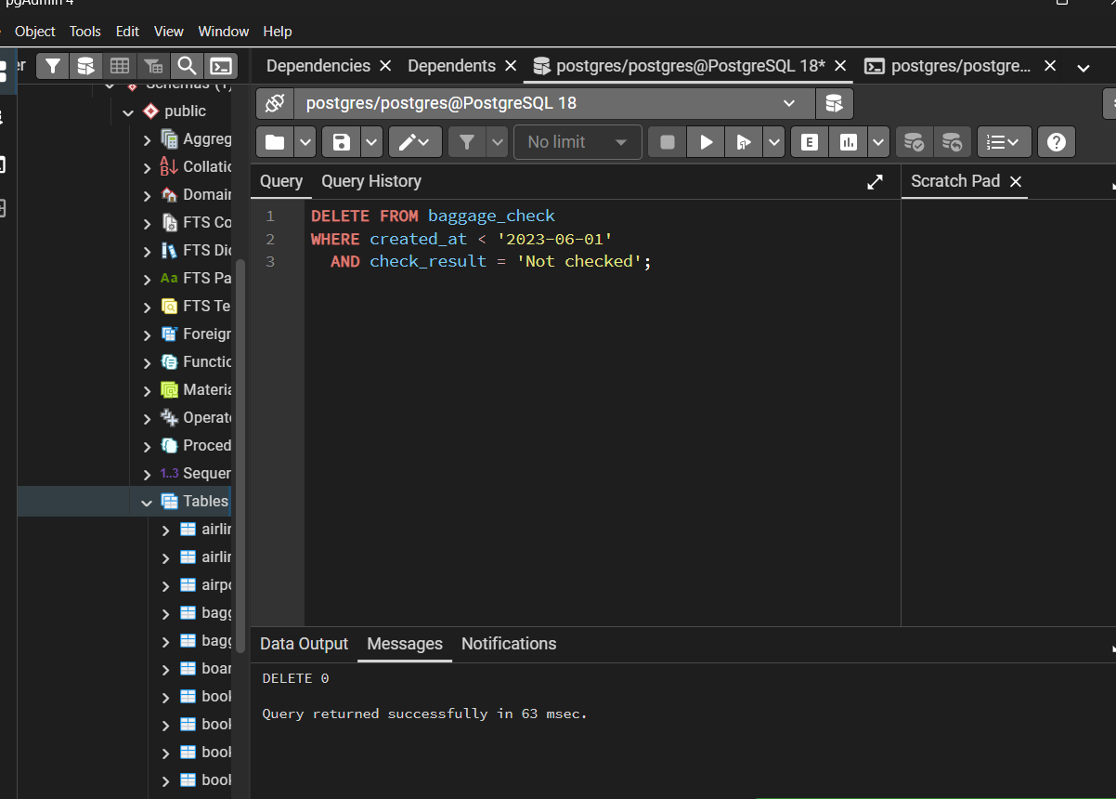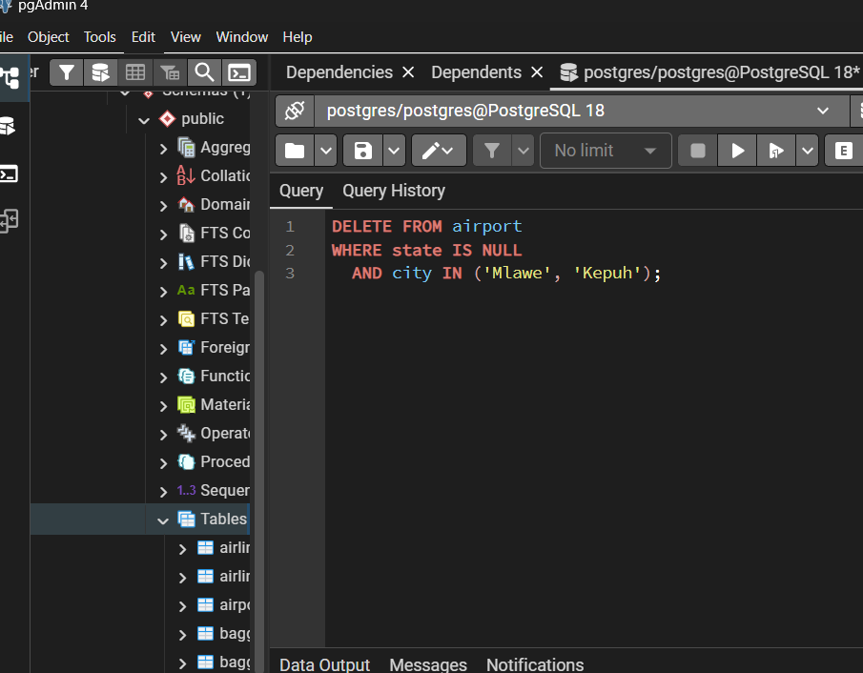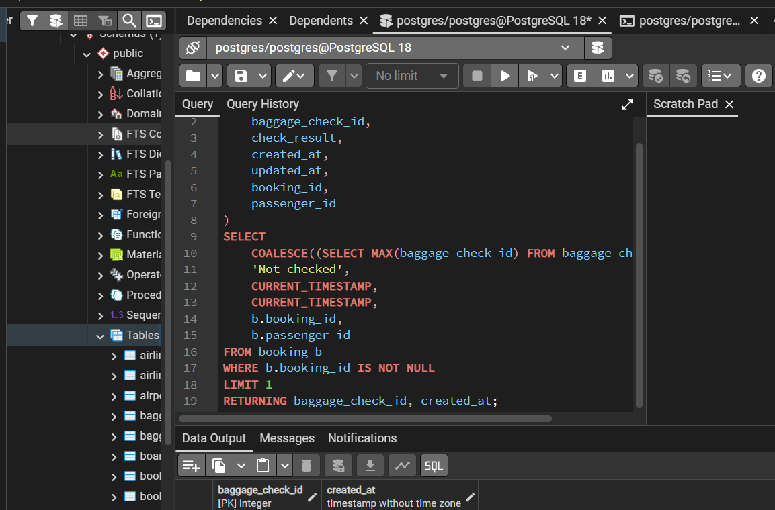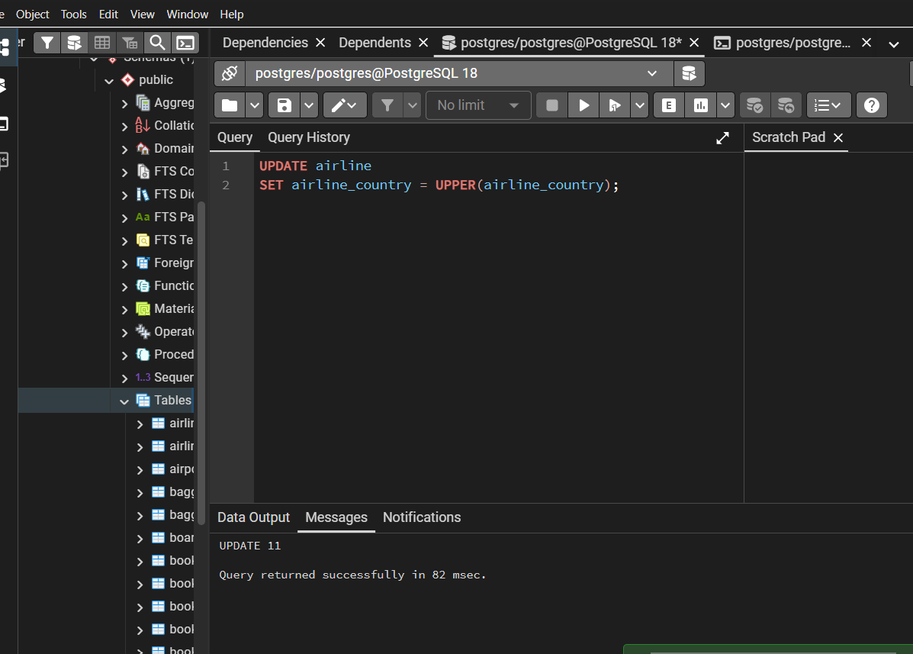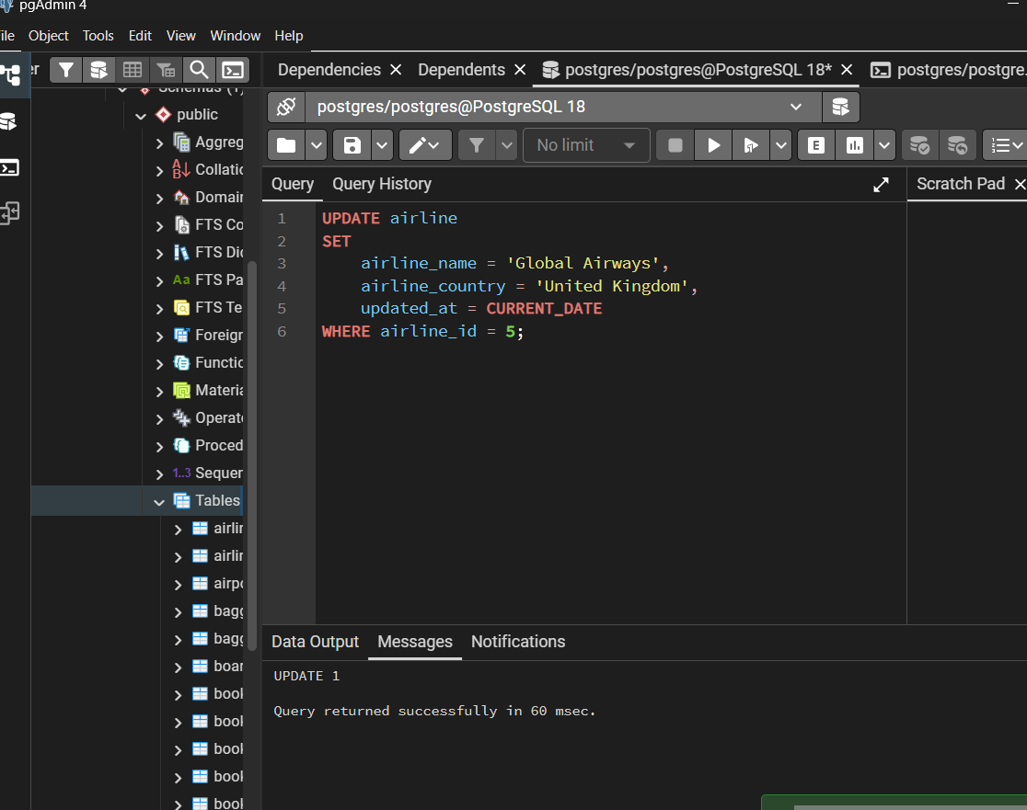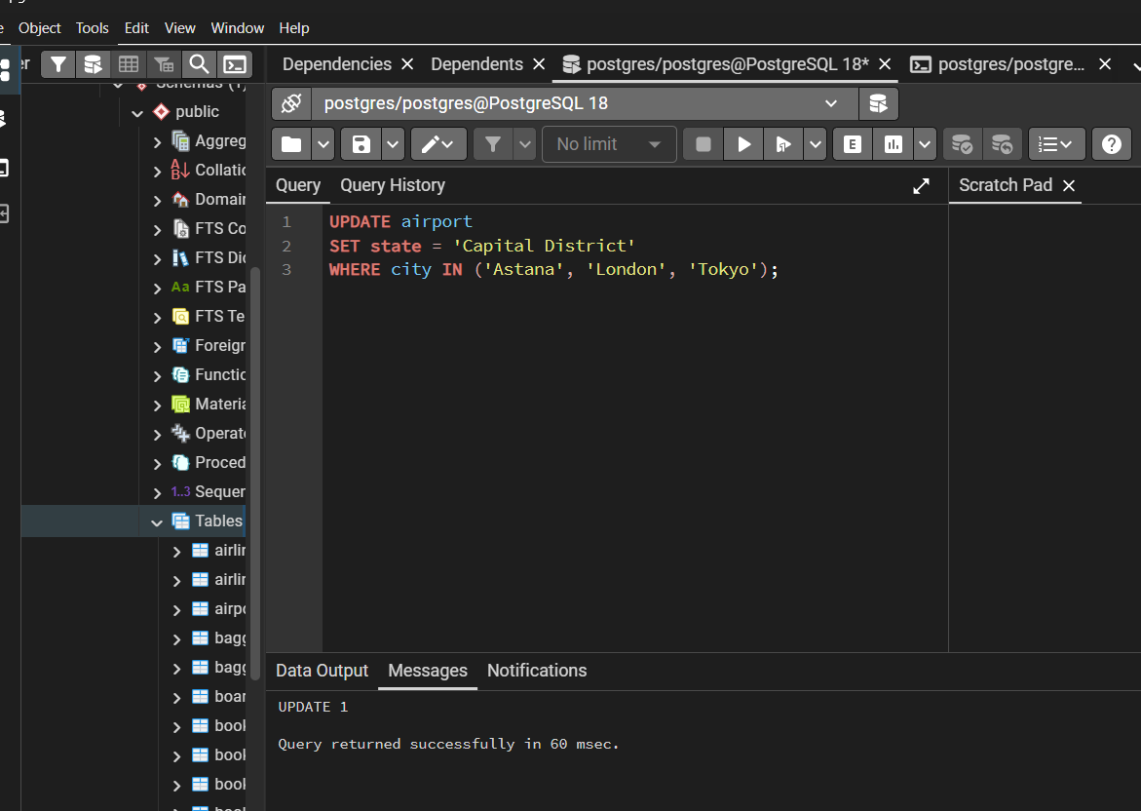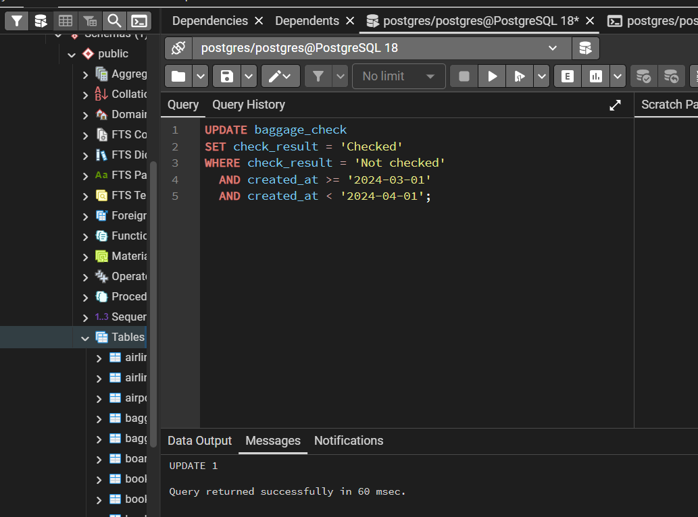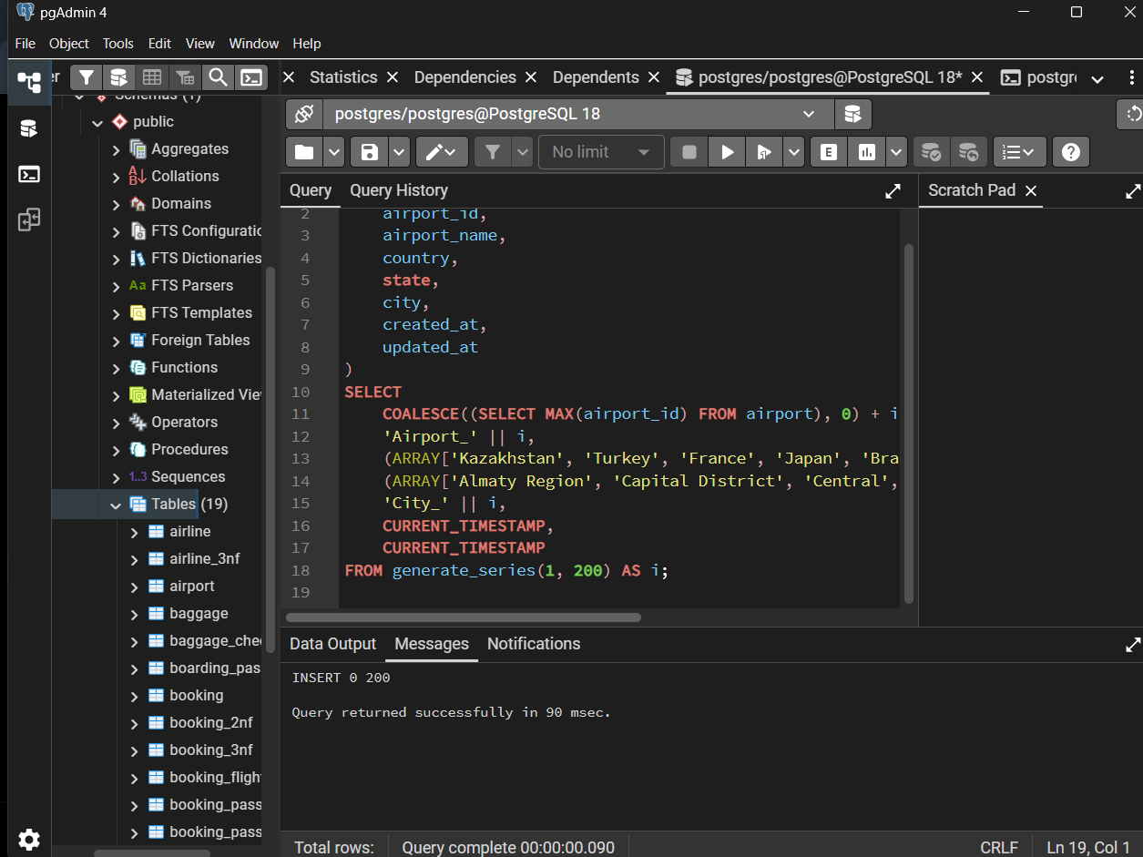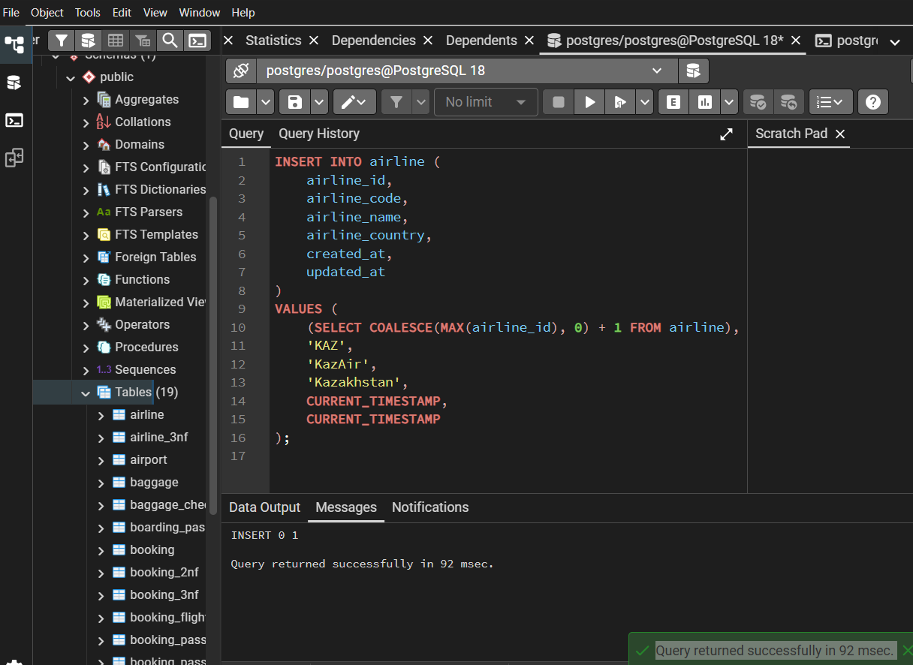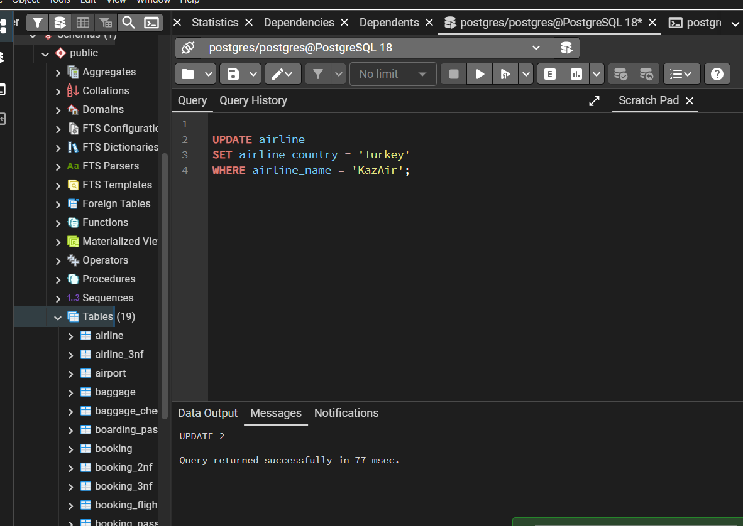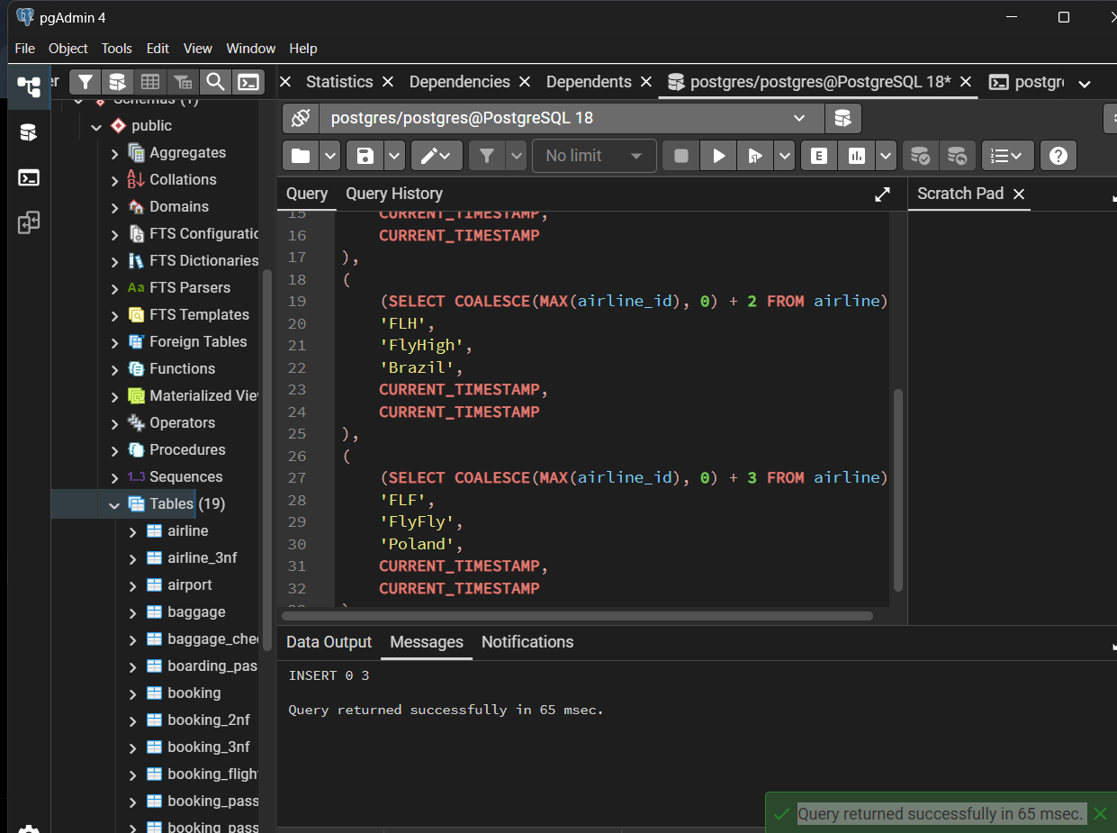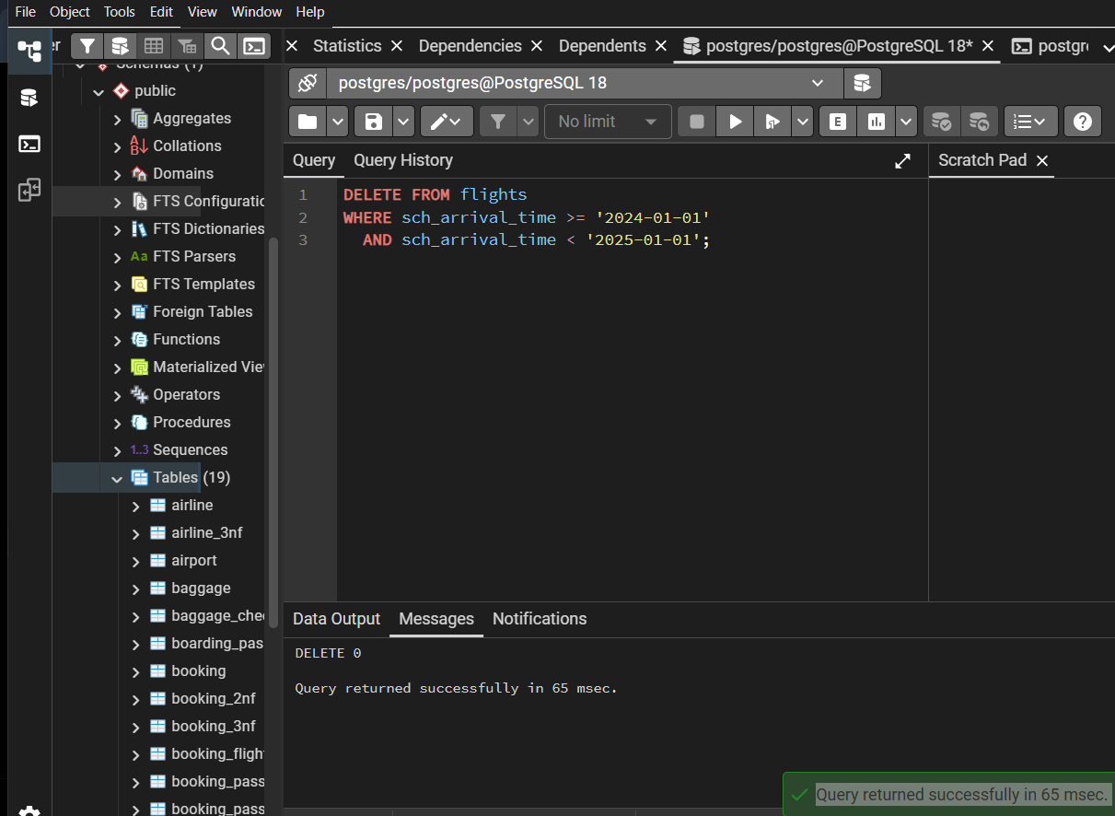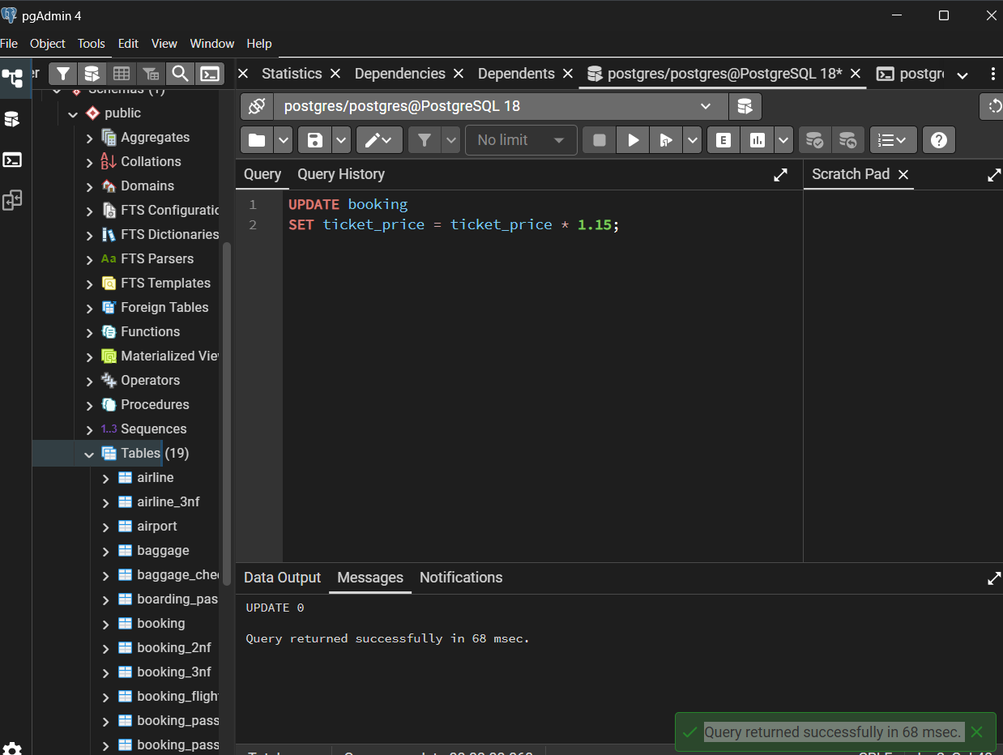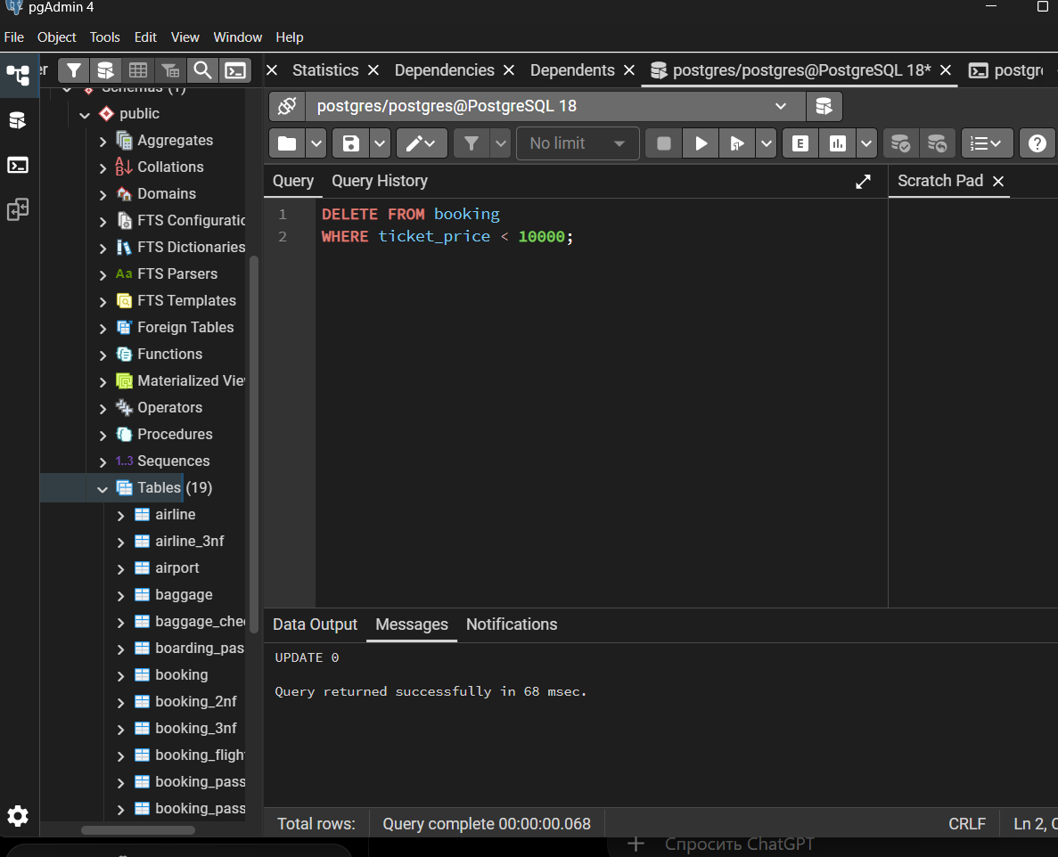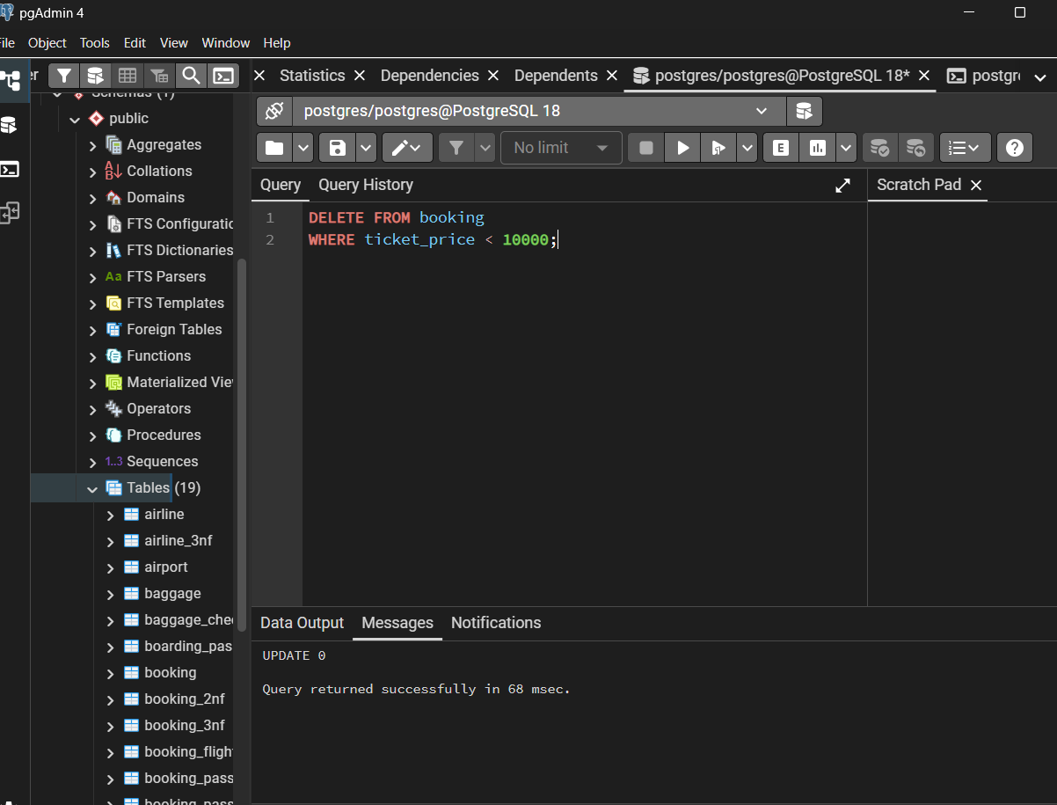Понял 😄 Ты хочешь описание всех 15 заданий, чтобы вставить в отчёт. Вот готовый вариант:
- Task 1: Generated and inserted 200 random records into the airport table.
- Task 2: Added a new airline named KazAir with Kazakhstan as its country.
- Task 3: Updated the country of KazAir from Kazakhstan to Turkey.
- Task 4: Added three new airlines: AirEasy from France, FlyHigh from Brazil, and FlyFly from Poland.
- Task 5: Deleted all flights with an arrival date in 2024.
- Task 6: Increased the price of all tickets in the booking table by 15%.
- Task 7: Deleted all tickets with a price lower than 10000.
- Task 8: Assigned the airline code UNK to airlines whose airline_code was missing (NULL).
- Task 9: Deleted baggage check records created before June 1, 2023 that still had the status “Not checked”.
- Task 10: Deleted airport records where the state was missing and the city was either Mlawe or Kepuh.
- Task 11: Inserted a new baggage inspection record with the status “Not checked” and returned its newly generated ID and creation timestamp.
- Task 12: Converted all airline country names to uppercase using the UPPER() function.
- Task 13: Updated airline ID 5, changing its name to Global Airways, country to United Kingdom, and update timestamp to the current date/time.
- Task 14: Set the state field to “Capital District” for airports located in Astana, London, and Tokyo.
- Task 15: Changed all baggage checks created in March 2024 with the status “Not checked” to “Checked”.
